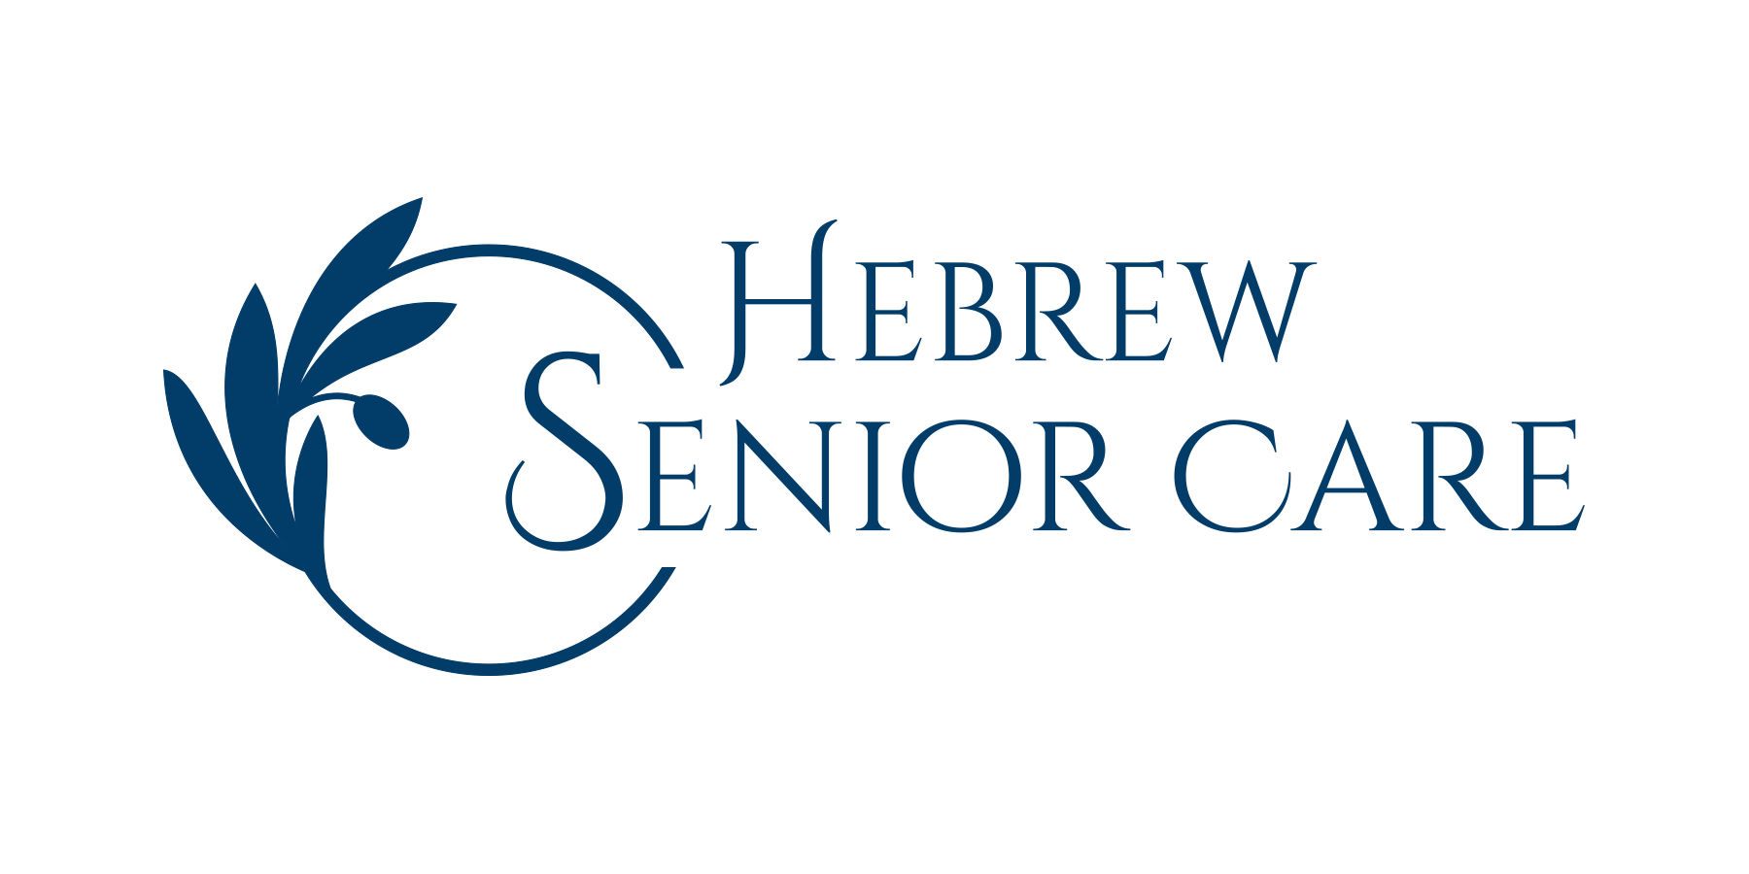
Mission:
Hebrew Senior Care provides the community with a broad spectrum of exceptional health care and aging services tailored to the needs of each individual.

Vision:
In all of our programs and services, we will strive to be the provider of choice.

Values:
- We strive to earn the trust of all we serve by practicing transparency in governance and operations, and by living our vision, mission, and core values.
- We are a non-sectarian organization proud of our historical roots in the Jewish community.
- We respect the importance of the need for individual choice as essential to providing quality services.
- We assure informed, dignified quality care to all regardless of source of payment for services.
- We acknowledge that spirituality is an important dimension of well being.

